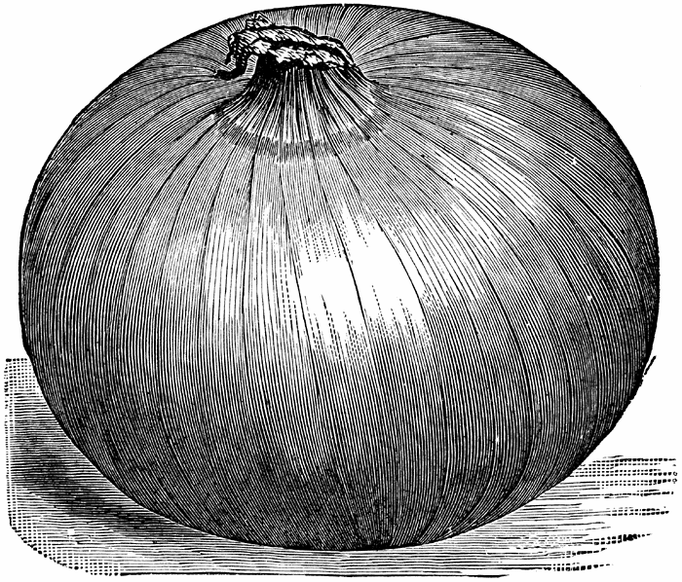
Tips for Growing Onions with Large Bulbs
If you use a fish emulsion product and a compost tea or soil amendment as a side dressing, the onions will also have all the phosphorus, nitrogen and other trace minerals necessary for really sweet onions.
If you want larger bulbs, here are some other tips. Grow the onions until the stalks are about 9” tall, then trim the green stalks in half (so about 4-5” remains of the stalk). Then, let them grow again until they are about 12” tall, then cut in half again to 6”. Do this 3 times, which will force more energy into the roots and will promote larger bulbs.
Then after 3 times, wait until the onions mature. When you see 4” of dead brown at top of the stalks, cut water off to the onions at this point and wait a month before harvesting. This will promote a better storage capability for the onions and better sweetness. At this point, knock over the stalks with rake in one direction 90 degrees down to the ground, leaving the bulbs still in the ground. Then after a week, pull the bulbs and lay them on that side, and let them dry for at least 2 days. Then flip them over the other direction and dry the other sides. By letting them cure at least 3 days in the sun, it will make them less acidic and it will turn enzymes into sweetness so they won’t affect sensitive tummies.
Then, after this, don’t remove the dirt on the onions themselves because this will fool the onions that they are still in the ground and they won’t start to break down. This will give you 6 more weeks of storage. You can simply braid them if you like and hang them in cool spot. Onions that generally only last about a month can last up to 3 months this way!

